

MD.070 Application Extensions

Technical Design

2 Degrees

Oracle E Business Suite R12

Integration to Basware

AP.01.07 2D Suppliers XML File Creation

v1.0

**Dart Arellano**

07 June 2018

Document Control

Document History

|  |  |  |  |
| --- | --- | --- | --- |
| Version | Name | Date | Comment |
| Draft1A | Dart Arellano | 12-June-2018 | Initial version |
| 1.0 | Dart Arellano |  | Approved and released to 2 Degrees |
|  |  |  |  |
|  |  |  |  |

Distribution

|  |  |  |  |
| --- | --- | --- | --- |
| Name | Title/Position | Company | Date |
|  | Library Master | DXC RED ROCK | 12-June-2018 |
| Miles Harvey | Internal Systems Support Lead | 2 Degrees |  |
| John Marais | ePMO Project Manager | 2 Degrees |  |
| Matt Farrer | Project Manager/Consulting Manager | DXC RED ROCK |  |

Reviewers

|  |  |  |  |
| --- | --- | --- | --- |
| Name | Title/Position | Review Date | Reviewed Version |
| Dirk Verbeek | Technical Consultant | 11-June-2018 | Draft1A |
| Matt Farrer | Project Manager/Consulting Manager | 11-June-2018 | Draft1A |

Approval

|  |  |  |  |
| --- | --- | --- | --- |
| Name | Title/Position | Date | Approval |
|  |  |  |  |

Table of Contents

1 Technical Overview 4

1.1 Approach 4

1.2 Module List 4

1.3 Prerequisite 4

1.4 Document Reference 4

2 2D Suppliers XML File Creation - Concurrent Program Logic 5

2.1 Report Design 5

2.1.1 SQL Queries 5

2.1.2 Data Model 5

2.1.3 Report Groups and Elements 6

2.1.4 Data Links 9

2.1.5 Triggers 9

2.2 Program Executable 9

2.3 Calling Arguments 10

2.4 Incompatibility 10

2.5 Profile Option 10

2.6 Output File 10

2.7 Log File 11

3 Database Design 12

3.1 Database Diagram 12

3.2 Database Objects 12

3.2.1 Tables 12

3.2.2 Views 12

4 Installation Instructions 13

4.1 Code Release Cycle 13

5 Implementation Notes 14

5.1 Coding Summary 14

5.2 Program Files 14

5.3 Testing Summary 14

6 Open and Closed Document Issues 15

6.1 Open Issues 15

6.2 Closed Issues 15

# Technical Overview

This document defines the technical components required to implement customisation . This Application Extension Technical Design document complements the Application Extension Functional Design document that addresses Suppliers (master data) for the Basware P2P Solution, consider the set to be the complete detailed design.

## Approach

* Build a report with XML output using Oracle Reports Developer 10g
* Design independent SQL query for each entity object: Supplier Site, Bank Accounts, Identifiers, Addresses and Additional Data to implement modularity
* Add a post run report routine to copy the output file from APPLOUT and place it in to the target Basware outbound directory
* Register the Oracle Report as a concurrent program to run overnight on a regular basis

## Module List

|  |  |
| --- | --- |
| Concurrent Program |  |

## Prerequisite

The Interface Framework common API delivers a number pre-built functions and procedures regularly used across many interface requirements. Customisation uses some of the accessible functionality offered, hence installation of Interface Framework API is required.

|  |  |
| --- | --- |
| Database Packages | XXFND_COMMON_PKG  XXFND_COMMON_INT_PKG |
| Concurrent Programs | 2D Common Interface Errors Report  2D Common Interface Run Report |

## Document Reference

| Doc ID | File Name | Date | Author |
| --- | --- | --- | --- |
|  |  |  |  |
| IDD 1.15 | Two Degrees Interface Description Document_v1.15.pdf | 05-May-2018 | Raimo Herttua |
| MD.050 (Supplier) | MD 050 Supplier Functional Specification v0.5.docx | 30-May-2018 | Jennifer Pole  Vaughn Hunt |

# 2D Suppliers XML File Creation - Concurrent Program Logic

Concurrent program is a report used for extracting data from Oracle AP Suppliers. The Suppliers data extract form part of the master data requirement of the Basware P2P Solution. Suppliers extract schedule is incremental but with the option to support full data extract when and if required.

## Report Design

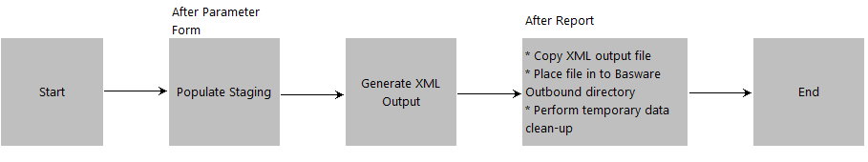

### SQL Queries

Q1_SUPPLIERS: Data Group 🡪 G1_SUPPLIERS

Q2_SUPPLIER_IDENTIFIERS: Data Group 🡪 G2_SUPPLIER_IDENTIFIERS

Q3_BANK_ACCOUNTS: Data Group 🡪 G3_BANK_ACCOUNTS

Q4_ADDITIONAL_DATA: Data Group 🡪 G4_ADDITIONAL_DATA

Q5_SUPPLIER_ADDRESSES: Data Group 🡪 G5_SUPPLIER_ADDRESSES

Q6_ADDRESS_PARTS: Data Group 🡪 G6_ADDRESS_PARTS

### Data Model

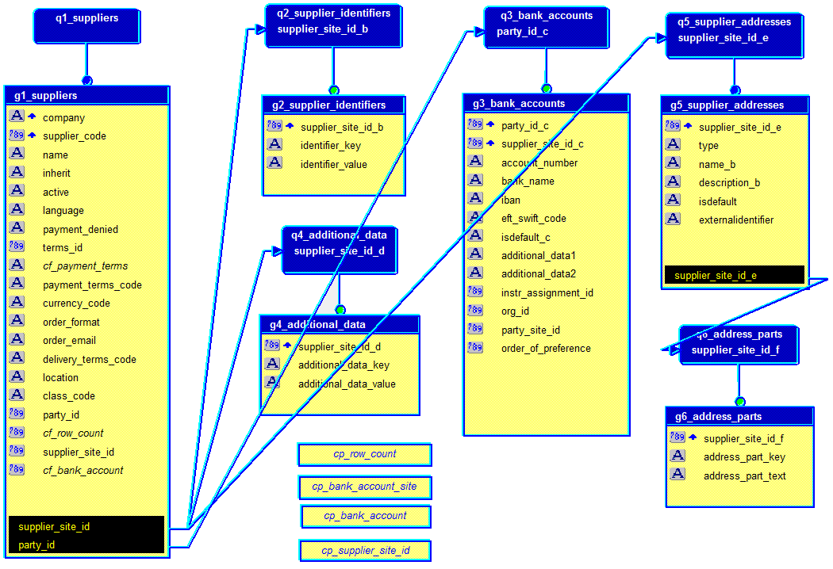

### Report Groups and Elements

| **Group** | **Element: Source Table and Column** | **XML Path** | **Derivation/Comment** |
| --- | --- | --- | --- |
| G1_SUPPLIERS | AP_SUPPLIERS_SITES_ALL.ORG_ID | /Company | DECODE(org_id, 82, '01', 453, '07', 452, '06') |
| G1_SUPPLIERS | AP_SUPPLIER_SITES_ALL.VENDOR_SITE_ID | /Code |  |
| G1_SUPPLIERS | AP_SUPPLIERS.VENDOR_NAME  AP_SUPPLIER_SITES_ALL.VENDOR_SITE_CODE | /Name | vendor_name || ' [' || vendor_site_code || ']' |
| G1_SUPPLIERS |  | /Inherit | Constant ‘false’ |
| G1_SUPPLIERS | AP_SUPPLIERS.END_DATE_ACTIVE  AP_SUPPLIERS.INACTIVE_DATE | /Active | DECODE(SIGN(SYSDATE - LEAST(NVL(end_date_active, SYSDATE + 1), NVL(inactive_date, SYSDATE + 1))), 1, 'FALSE', 'TRUE') |
| G1_SUPPLIERS |  | /Language | xxap_suppliers_xml_pkg.get_language_code |
| G1_SUPPLIERS | AP_SUPPLIER_SITES_ALL.HOLD_FUTURE_PAYMENTS_FLAG  AP_SUPPLIERS.HOLD_FUTURE_PAYMENTS_FLAG | /PaymentDenied | DECODE(SIGN(DECODE(hold_all_payments_flag, 'Y', 1, 0) +  DECODE(hold_future_payments_flag, 'Y', 1, 0) +  DECODE(hold_all_payments_flag, 'Y', 1, 0) +  DECODE(hold_future_payments_flag, 'Y', 1, 0)), 1, 'TRUE', 'FALSE') |
| G1_SUPPLIERS | FND_LOOKUP_VALUES.LOOKUP_CODE  AP_TERMS.NAME | /PaymentTermCode | cf_payment_terms |
| G1_SUPPLIERS | AP_SUPPLIER_SITES_ALL.INVOICE_CURRENCY_CODE | /Currency |  |
| G1_SUPPLIERS | AP_SUPPLIER_SITES_ALL.SUPPLIER_NOTIF_METHOD | /OrderFormat | DECODE(supplier_notif_method, 'XML', 'xml', 'EMAIL', 'email', 'none') |
| G1_SUPPLIERS | AP_SUPPLIER_SITES_ALL.EMAIL_ADDRESS | /OrderEmail |  |
| G1_SUPPLIERS |  | /DeliveryTermCode |  |
| G1_SUPPLIERS | AP_SUPPLIER_SITES_ALL.VENDOR_SITE_CODE | /Location |  |
| G1_SUPPLIERS | AP_SUPPLIER_SITES_ALL.ATTRIBUTE3 | /ClasificationCode |  |
| G2_SUPPLIER_IDENTIFIERS |  | /Supplieridentifiers/Supplieridentifier/key | Constant ‘DUNS’ |
| G2_SUPPLIER_IDENTIFIERS | AP_SUPPLIER_SITES_ALL.DUNS_NUMBER | /Supplieridentifiers/Supplieridentifier/value |  |
| G2_SUPPLIER_IDENTIFIERS |  | /Supplieridentifiers/Supplieridentifier/key | Constant ‘PARTY_ID’ |
| G2_SUPPLIER_IDENTIFIERS | AP_SUPPLIER_SITES_ALL.VAT_REGISTRATION_NUM  AP_SUPPLIERS.VAT_REGISTRATION_NUM | /Supplieridentifiers/Supplieridentifier/value |  |
| G3_BANK_ACCOUNTS | IBY_EXT_BANK_ACCOUNTS.BANK_ACCOUNT_NU | /BankAccounts/SupplierBankAccount/Bban |  |
| G3_BANK_ACCOUNTS | CE_BANK_BRANCHES_V.BANK_NAME | /BankAccounts/SupplierBankAccount/Name |  |
| G3_BANK_ACCOUNTS | IBY_EXT_BANK_ACCOUNTS.IBAN | /BankAccounts/SupplierBankAccount/Iban |  |
| G3_BANK_ACCOUNTS | IBY_EXT_BANK_ACCOUNTS.EFT_SWIFT_CODE | /BankAccounts/SupplierBankAccount/Swift |  |
| G3_BANK_ACCOUNTS |  | /BankAccounts/SupplierBankAccount/IsDefault | Constant ‘True’ |
| G3_BANK_ACCOUNTS |  | /BankAccounts/SupplierBankAccount/AdditionalData1 |  |
| G3_BANK_ACCOUNTS |  | /BankAccounts/SupplierBankAccount/AdditionalData2 |  |
| G4_ADDITIONAL_DATA |  | /AdditionalDatas/AdditionalData/key | Constant ‘PO_EXEMPT’ |
| G4_ADDITIONAL_DATA | AP_SUPPLIER_SITES_ALL.PURCHASING_SITE_FLAG | /AdditionalDatas/AdditionalData/value |  |
| G4_ADDITIONAL_DATA |  | /AdditionalDatas/AdditionalData/key | Constant ‘GST_REG_NO’ |
| G4_ADDITIONAL_DATA | AP_SUPPLIER_SITES_ALL.VAT_REGISTRATION_NUM  AP_SUPPLIERS.VAT_REGISTRATION_NUM | /AdditionalDatas/AdditionalData/value |  |
| G4_ADDITIONAL_DATA |  | /AdditionalDatas/AdditionalData/key | Constant ‘TAX_CODE’ |
| G4_ADDITIONAL_DATA | AP_SUPPLIER_SITES_ALL.VAT_CODE | /AdditionalDatas/AdditionalData/value |  |
| G4_ADDITIONAL_DATA |  | /AdditionalDatas/AdditionalData/key | Constant ‘STREET_NAME’ |
| G4_ADDITIONAL_DATA | AP_SUPPLIER_SITES_ALL.ADDRESS_LINE1  AP_SUPPLIER_SITES_ALL.ADDRESS_LINE2 | /AdditionalDatas/AdditionalData/value | Combine Address Line 1 and address line 2 into street_name. Use a comma and space separator between Line 1 and Line 2 if Line 1 and 2 is not Null. |
| G4_ADDITIONAL_DATA |  | /AdditionalDatas/AdditionalData/key | Constant ‘ADD_STREET_NAME’ |
| G4_ADDITIONAL_DATA | AP_SUPPLIER_SITES_ALL.ADDRESS_LINE3  AP_SUPPLIER_SITES_ALL.ADDRESS_LINE4 | /AdditionalDatas/AdditionalData/value | Combine address Line 3 and address line 4 into ADD_STREET_NAME. Use a comma and space separator between Line 3 and Line 4 in Line 3 and 4 if not Null. |
| G4_ADDITIONAL_DATA |  | /AdditionalDatas/AdditionalData/key | Constant ‘CITY_NAME’ |
| G4_ADDITIONAL_DATA | AP_SUPPLIER_SITES_ALL.CITY | /AdditionalDatas/AdditionalData/value |  |
| G4_ADDITIONAL_DATA |  | /AdditionalDatas/AdditionalData/key | Constant ‘POSTAL_ZONE’ |
| G4_ADDITIONAL_DATA | AP_SUPPLIER_SITES_ALL.ZIP | /AdditionalDatas/AdditionalData/value |  |
| G4_ADDITIONAL_DATA |  | /AdditionalDatas/AdditionalData/key | ‘COUNTRY’ |
| G4_ADDITIONAL_DATA | AP_SUPPLIER_SITES_ALL.COUNTRY  FND_TERRITORIES_TL.TERRITORY_SHORT_NAME | /AdditionalDatas/AdditionalData/value | Full country name ex: New Zealand |
| G5_SUPPLIER_ADDRESSES |  | /SuppllierAddresses/SupplierAddress/Type | Constant ‘PostalAddress’ |
| G5_SUPPLIER_ADDRESSES | HZ_PARTY_SITES. PARTY_SITE_NAME | /SuppllierAddresses/SupplierAddress/Name |  |
| G5_SUPPLIER_ADDRESSES |  | /SuppllierAddresses/SupplierAddress/Description |  |
| G5_SUPPLIER_ADDRESSES |  | /SuppllierAddresses/SupplierAddress/IsDefault | Constant ‘True’ |
| G5_SUPPLIER_ADDRESSES | AP_SUPPLIER_SITES_ALL.ORG_ID  AP_SUPPLIER_SITES_ALL.VENDOR_SITE_ID | /SuppllierAddresses/SupplierAddress/ExternalIdentifier | ORG_ID || VENDOR_SITE_ID |
| G6_ADDRESS_PARTS |  | /SuppllierAddresses/SupplierAddress/AddressParts/SupplierAddressPart/AddressPartKey | Constant ‘STREET_NAME’ |
| G6_ADDRESS_PARTS | AP_SUPPLIER_SITES_ALL.ADDRESS_LINE1  AP_SUPPLIER_SITES_ALL.ADDRESS_LINE2 | /SuppllierAddresses/SupplierAddress/AddressParts/SupplierAddressPart/AddressPartText | Combine address Line 1 and address line 2. Use a comma and space separator between Line 1 and Line 2 if Line 1 and 2 is not Null. |
| G6_ADDRESS_PARTS |  | /SuppllierAddresses/SupplierAddress/AddressParts/SupplierAddressPart/AddressPartKey | Constant ‘ADD_STREET_NAME’ |
| G6_ADDRESS_PARTS | AP_SUPPLIER_SITES_ALL.ADDRESS_LINE3  AP_SUPPLIER_SITES_ALL.ADDRESS_LINE4 | /SuppllierAddresses/SupplierAddress/AddressParts/SupplierAddressPart/AddressPartText | Combine address Line 3 and address line 4. Use a comma and space separator between Line 3 and Line 4 if line 3 and 4 is not Null |
| G6_ADDRESS_PARTS |  | /SuppllierAddresses/SupplierAddress/AddressParts/SupplierAddressPart/AddressPartKey | Constant ‘CITY_NAME’ |
| G6_ADDRESS_PARTS | AP_SUPPLIER_SITES_ALL.CITY | /SuppllierAddresses/SupplierAddress/AddressParts/SupplierAddressPart/AddressPartText |  |
| G6_ADDRESS_PARTS |  | /SuppllierAddresses/SupplierAddress/AddressParts/SupplierAddressPart/AddressPartKey | Constant ‘POSTAL_ZONE’ |
| G6_ADDRESS_PARTS | AP_SUPPLIER_SITES_ALL.ZIP | /SuppllierAddresses/SupplierAddress/AddressParts/SupplierAddressPart/AddressPartText |  |
| G6_ADDRESS_PARTS |  | /SuppllierAddresses/SupplierAddress/AddressParts/SupplierAddressPart/AddressPartKey | Constant ‘COUNTRY’ |
| G6_ADDRESS_PARTS | AP_SUPPLIER_SITES_ALL.COUNTRY  FND_TERRITORIES_TL.TERRITORY_SHORT_NAME | /SuppllierAddresses/SupplierAddress/AddressParts/SupplierAddressPart/AddressPartText | Full country name |

### Data Links

G1_SUPPLIERS: PARTY_ID 🡪 Q3_BANK_ACCOUNTS: PARTY_ID

G1_SUPPLIERS: SUPPLIER_SITE_ID 🡪 Q2_SUPPLIER_IDENTIFIERS: SUPPLIER_SITE_ID

G1_SUPPLIERS: SUPPLIER_SITE_ID 🡪 Q4_ADDITIONAL_DATA: SUPPLIER_SITE_ID

G1_SUPPLIERS: SUPPLIER_SITE_ID 🡪 Q5_SUPPLIER_ADDRESSES: SUPPLIER_SITE_ID

G5_SUPPLIER_ADDRESSES: SUPPLIER_SITE_ID 🡪 Q6_ADDRESS_PARTS: SUPPLIER_SITE_ID

### Triggers

After Parameter Form Populate Suppliers XML staging table by calling the database package xxap_suppliers_xml_pkg.populate_staging.

After Report (1) Copy report output file in to the target Basware outbound directory by calling database package xxfnd_common_pkg.submit_move_file. (2) Perform clean-up of temporary data.

## Program Executable

| Field | Value |
| --- | --- |
|  |  |
| Executable | XXAPSUPPLIERS |
| Short Name | XXAPSUPPLIERS |
| Application | XXNZCL Custom Application |
| Description | 2D Supplier XML File Creation |
| Execute Method | Oracle Reports |
| Execute File Name | XXAPSUPPLIERS |

## Calling Arguments

| Argument | Prompt | Value Set | Default Value |
| --- | --- | --- | --- |
|  |  |  |  |
| p_include_org_id | Include Organizations | 150 Characters Optional | Constant: 82, 453, 452 |
| p_full_extract | Full Extract | Yes_No | Constant: No |
| p_test_data | Use Test Data | Yes_No | Constant: No |

## Incompatibility

| Application | Name | Scope | Type |
| --- | --- | --- | --- |
|  |  |  |  |
| XXNZCL Custom Application | 2D Supplier XML File Creation | Program | Domain |

## Profile Option

| Name | Level | Value Set | Default Value |
| --- | --- | --- | --- |
|  |  |  |  |
| 2D Outbound Directory for Basware | Site | n/a | /basware/outbound |
| 2D Notification Email Address for BW Interfaces | Site | n/a | email@email.com |

## Output File

Supplier XML Output file

<?xml version="1.0" encoding="UTF-8"?>

<!-- Generated by Oracle Reports version 10.1.2.3.0 -->

<DocumentElement>

<Supplier>

<Company>01</Company>

<Code>281199</Code>

<Name>VH Test Supplier [WELLINGTON]</Name>

<Inherit>false</Inherit>

<Active>TRUE</Active>

<Language>en-GB</Language>

<PaymentDenied>FALSE</PaymentDenied>

<Currency>NZD</Currency>

<OrderFormat>none</OrderFormat>

<OrderEmail></OrderEmail>

<DeliveryTermCode></DeliveryTermCode>

<Location>WELLINGTON</Location>

<ClassificationCode>NP</ClassificationCode>

<AdditionalDatas>

<AdditionalData>

<key>PO_EXEMPT</key>

<value>False</value>

</AdditionalData>

<AdditionalData>

<key>STREET_NAME</key>

<value>Address Line 1</value>

</AdditionalData>

<AdditionalData>

<key>COUNTRY</key>

<value>New Zealand</value>

</AdditionalData>

</AdditionalDatas>

<SupplierIdentifiers>

</SupplierIdentifiers>

<SupplierAddresses>

<SupplierAddress>

<Type>PostalAddress</Type>

<Name>Wellington (25087)</Name>

<Description></Description>

<IsDefault>True</IsDefault>

<ExternalIdentifier>82281199</ExternalIdentifier>

<AddressParts>

<SupplierAddressPart>

<AddressPartKey>STREET_NAME</AddressPartKey>

<AddressPartText>Address Line 1</AddressPartText>

</SupplierAddressPart>

<SupplierAddressPart>

<AddressPartKey>COUNTRY</AddressPartKey>

<AddressPartText>New Zealand</AddressPartText>

</SupplierAddressPart>

</AddressParts>

</SupplierAddress>

</SupplierAddresses>

<BankAccounts>

<SupplierBankAccount>

<Bban>12345</Bban>

<Name>ASB</Name>

<Swift></Swift>

<IsDefault>True</IsDefault>

<AdditionalData1></AdditionalData1>

<AdditionalData2></AdditionalData2>

</SupplierBankAccount>

</BankAccounts>

<PaymentTermCode>25THNEXTMONTH</PaymentTermCode>

</Supplier>

</DocumentElement>

## Log File

n/a

# Database Design

This section summarized new and changed database objects and data required to implement .

## Database Diagram

Data model shown on section 2.1.2 of this document depicts the relationship between the business object entities.

## Database Objects

### Tables

Custom table definition to support customisation

* XXAP_SUPPLIERS_XML_STG

### Views

n/a

# Installation Instructions

An automated installation script is provided to migrate customisation to the target environment.

Step 1: Place the TAR file -R-[release number].tar in $XXNZCL_TOP directory of the target environment (binary mode)

Step 2: Extract the contents of the TAR file

> cd $XXNZCL_TOP

> tar -xvf -R-[release number].tar

Step 3: Run the install script

> cd install

> chmod +x _install.sh

> ./_install.sh [db password] | tee _install.[release number].log

## Code Release Cycle

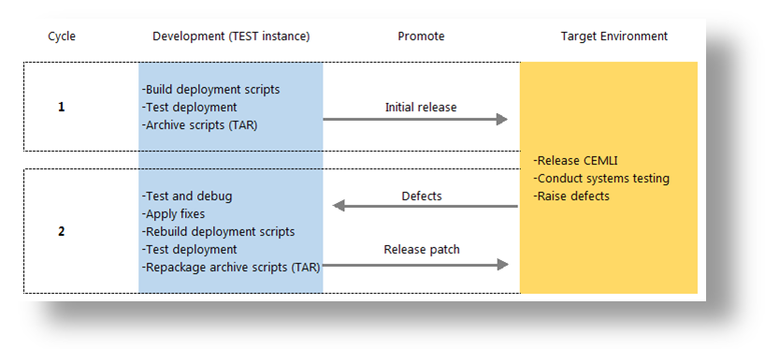

# Implementation Notes

This document describes exactly how was developed and implemented at 2 Degrees.

## Coding Summary

Development was done on Linux 2.6.32-431.el6.i686 server, host name snzclakl025.nzc.co.nz, to work with Release 12.1.3 of Oracle Applications. All coding follows the standards defined in Oracle E Business Suite Developer’s Guide Part No. E12897-4.

## Program Files

| Type | Name | Location |
| --- | --- | --- |
|  |  |  |
| DDL | XXAP_SUPPLIERS_XML_STG_DDL.sql | $XXNZCL_TOP/install/sql |
| Database Package | XXAP_SUPPLIERS_XML_PKG.pks | $XXNZCL_TOP/install/sql |
| Database Package | XXAP_SUPPLIERS_XML_PKG.pkb | $XXNZCL_TOP/install/sql |
| Loader | XXAPSUPPLIERS.ldt | $XXNZCL_TOP/import |
| Loader | XXAPREQGRP.ldt | $XXNZCL_TOP/import |
| Loader | XXADMREQGRP.ldt | $XXNZCL_TOP/import |
| Report | XXAPSUPPLIERS.rdf | $XXNZCL_TOP/reports/US |
| Install Script | AP.01.07_install.sh | $XXNZCL_TOP/install |

## Testing Summary

The customizations were tested in 2 Degrees' snzclakl025.nzc.co.nz TEST environment before promoting to the next target environment. See the related functional test scripts for more information.

# Open and Closed Document Issues

## Open Issues

|  |  |  |  |  |  |
| --- | --- | --- | --- | --- | --- |
| ID | Issue | Resolution | Responsibility | Target Date | Impact Date |
| 1. |  |  |  |  |  |
| 2. |  |  |  |  |  |

## Closed Issues

|  |  |  |  |  |  |
| --- | --- | --- | --- | --- | --- |
| ID | Issue | Resolution | Responsibility | Target Date | Impact Date |
| 1. |  |  |  |  |  |
| 2. |  |  |  |  |  |
| 3. |  |  |  |  |  |
| 4. |  |  |  |  |  |